### Web App For Startup Business

### Week4: Deploy Web App Service

**Students :**

1. **Ahmed Nasr Ahmed**
2. **Mohamed Mostafa**
3. **Abdulrahman Atef**
4. **Mahmoud Khaled**
5. **Ahmed Ali**
6. **Salah Ahmed**

### ****1. Web app****

#### ****Steps:****

**1-create the web app:**

-Navigate to the **Azure Portal** and select **Create a Resource**.

-Choose **Web App** from the resource list.

-Enter the necessary details for the Web App such as:

**-Web App Name**: FileUploadApp

**-Region**: UK South

**-Runtime Stack**: .Net8 (LTS)

**-Operating System**: Windows

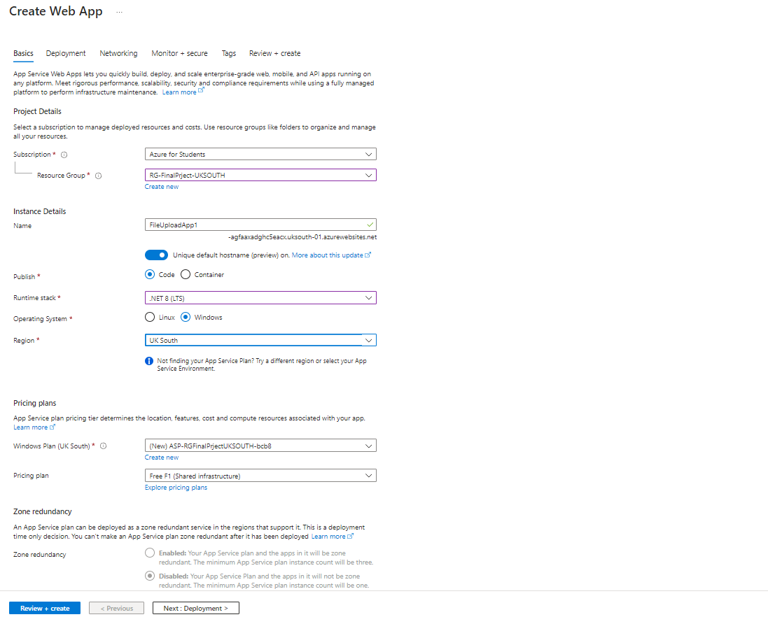

-Then click Review and Create

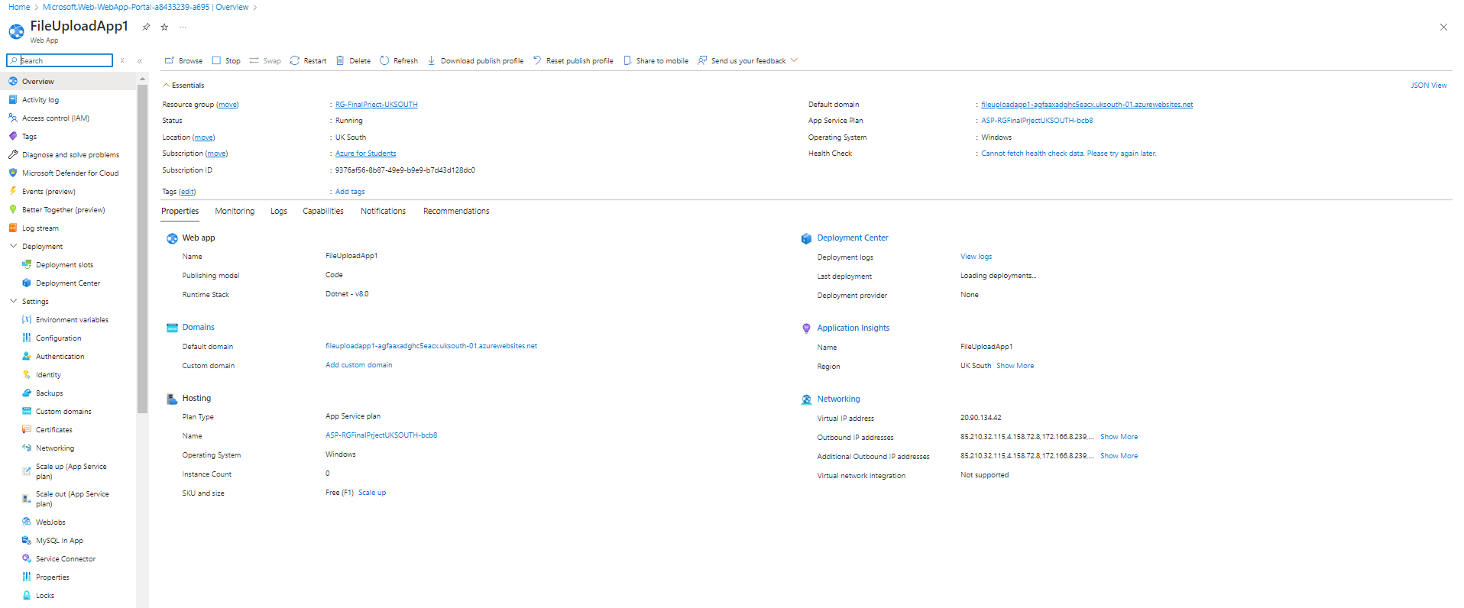

1. ****create the Web Site****

-Open visual studio preview 2022

-create a new project

-select ASP.NET Core Web App (model-view-control )

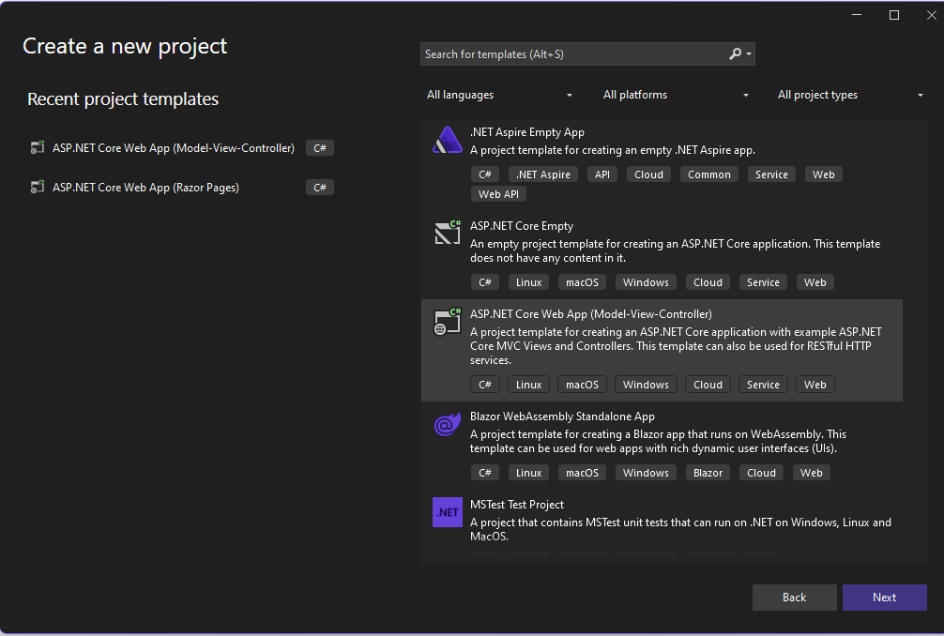

- put a name for the project

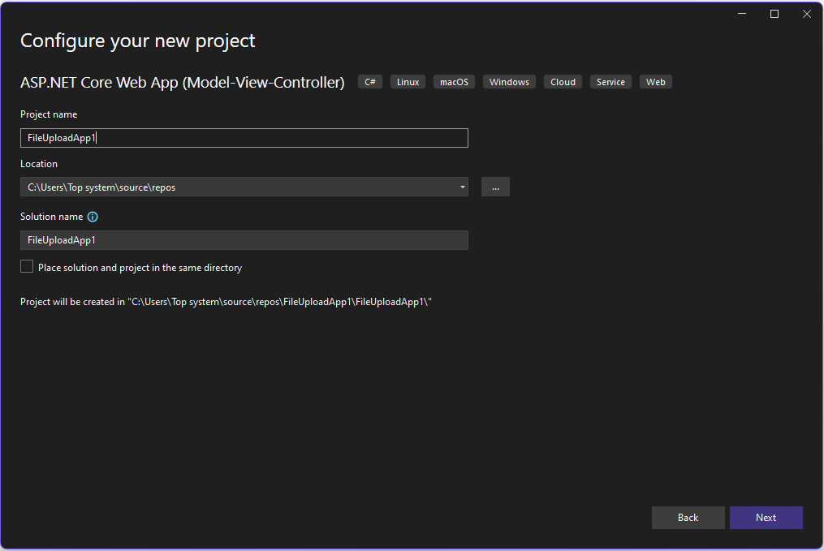

-put this code in **HomeController.cs** and put in it **StorageConnectionString** and the **FileShareName**

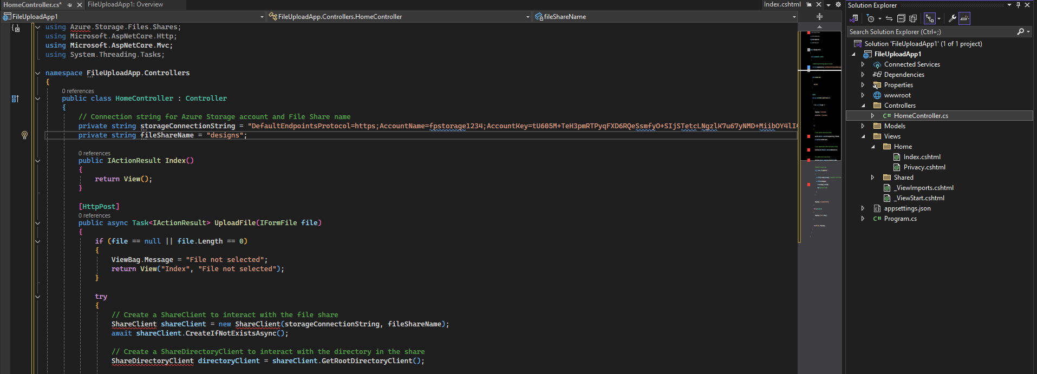

**-**put the code of the website so you can upload the designs and send it to the file share tha mounted in the HR computer

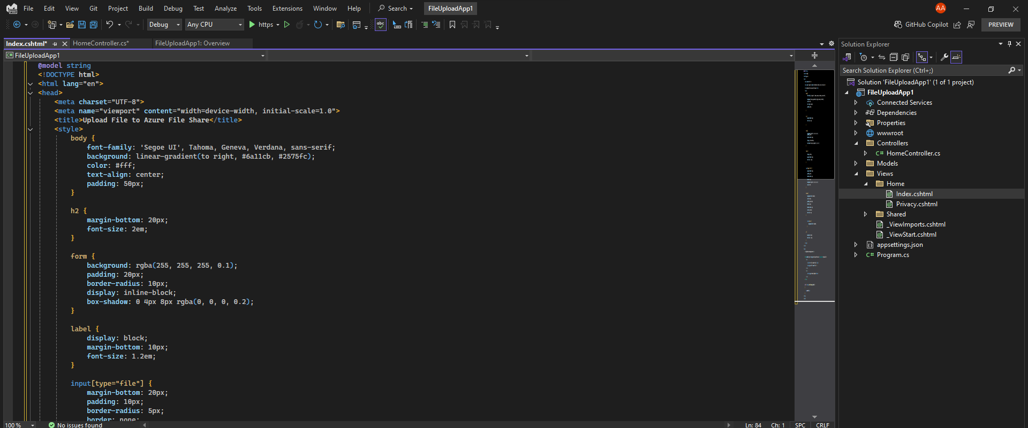

-install in visual studio **Azure.storage.files.shares**

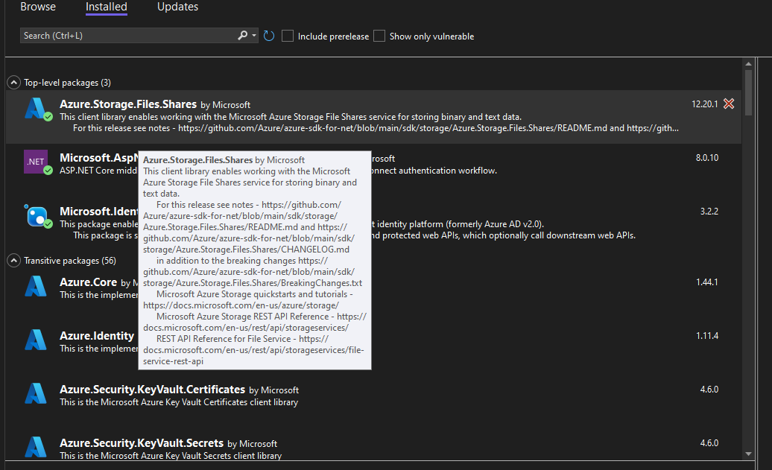

-After publishing the website , here is the website

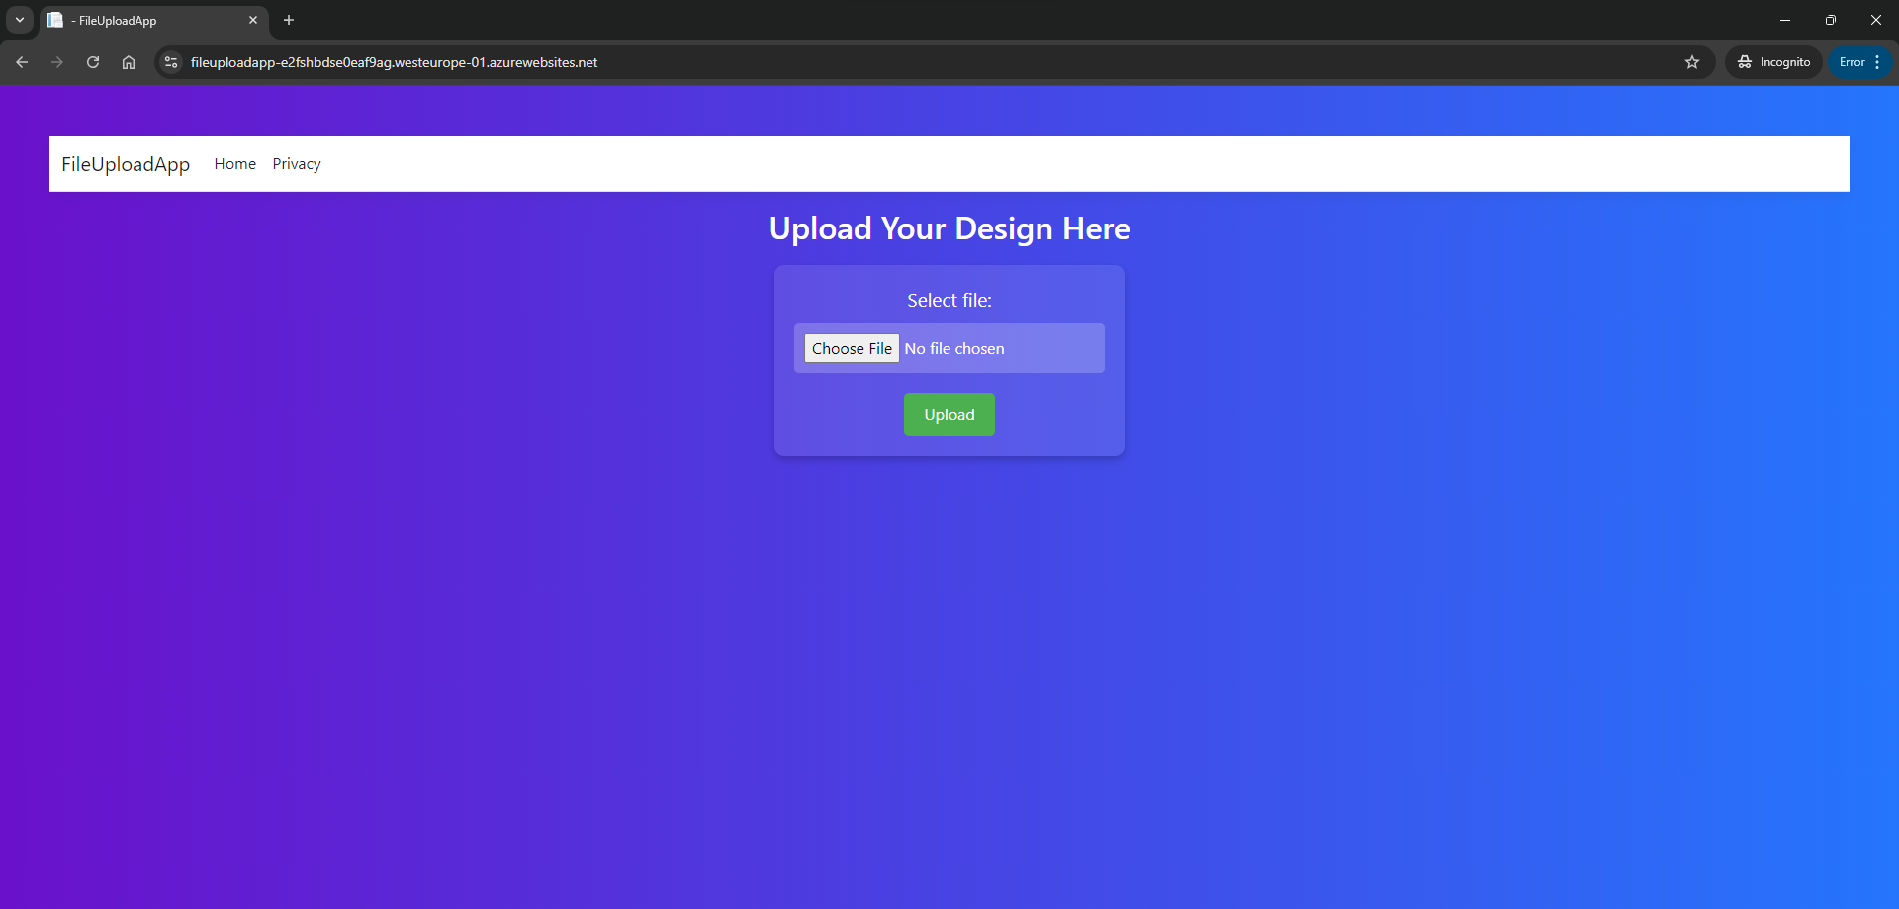

**3.Enable SSO in the Web App:**

**- Go to Authentication in the Web App**

**- click “ **add identity provider** “**

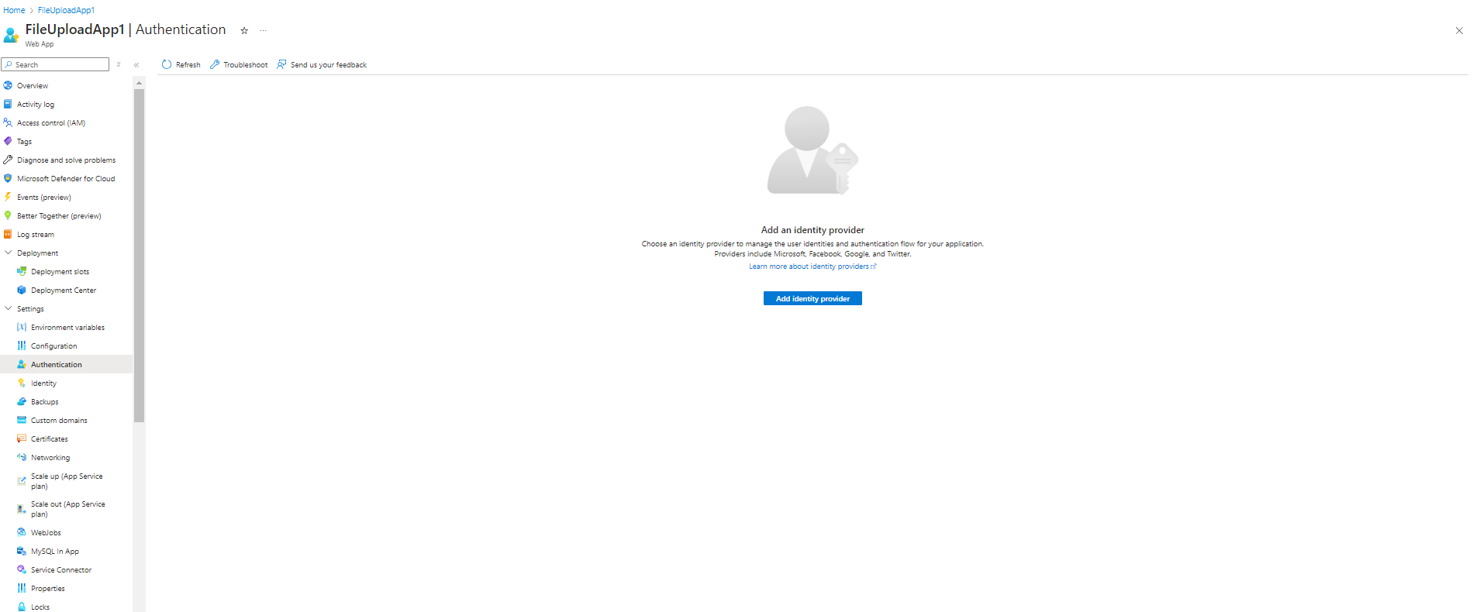

**- select microsoft so the only users that can enter the website are the users in the tenant of **Egypt University of informatics****

****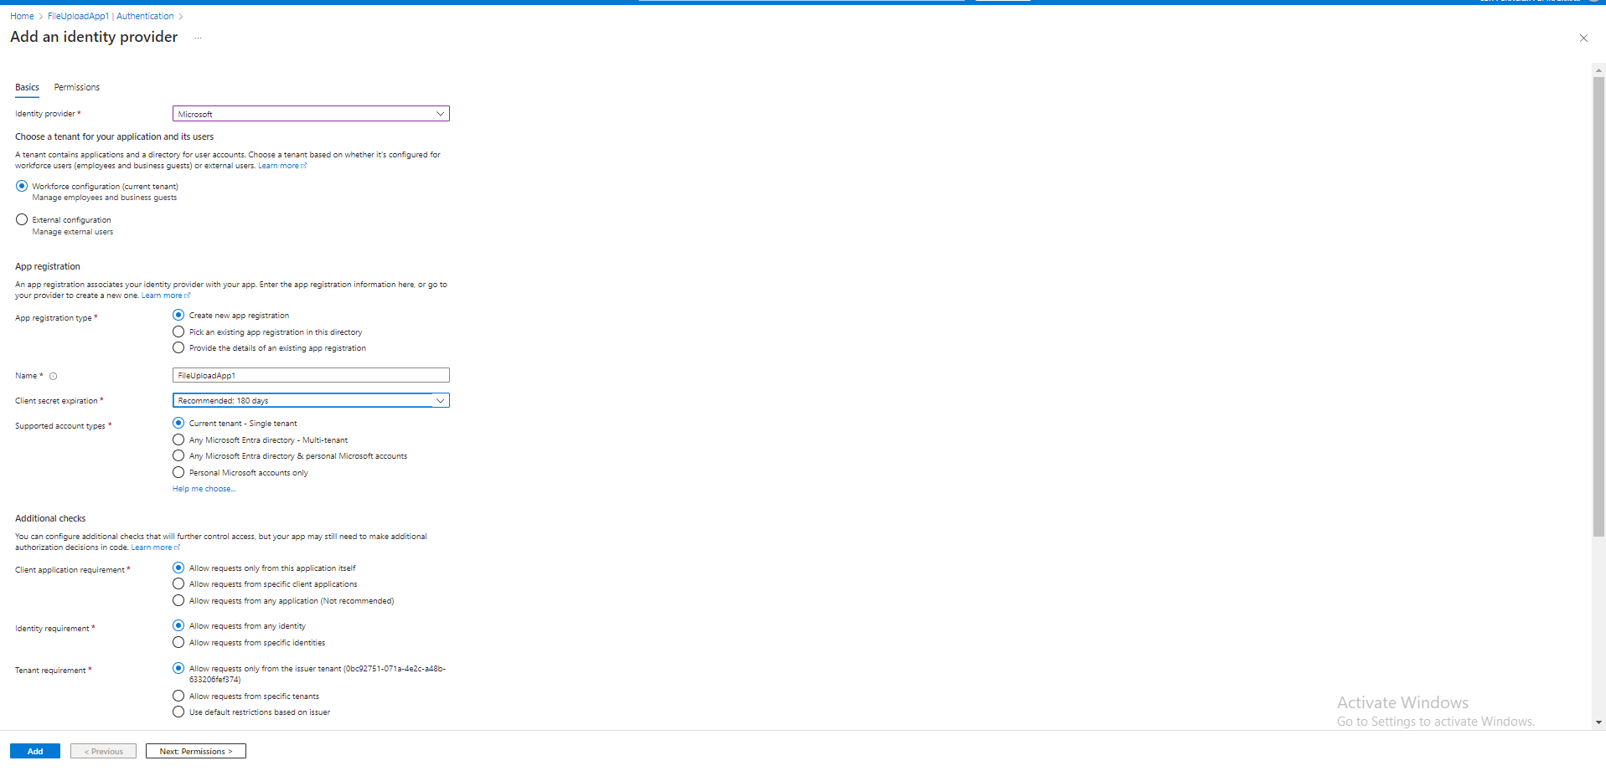****

****-** then click add and the **SSO** is enabled**

#### ****10****

**4.Testing The Web Site**

****-** Enter the web site from this link ”**<https://fileuploadapp-e2fshbdse0eaf9ag.westeurope-01.azurewebsites.net/> **“**

**- To enter the website you should be a user from Egypt University of informatics** tenant so you can be authenticated

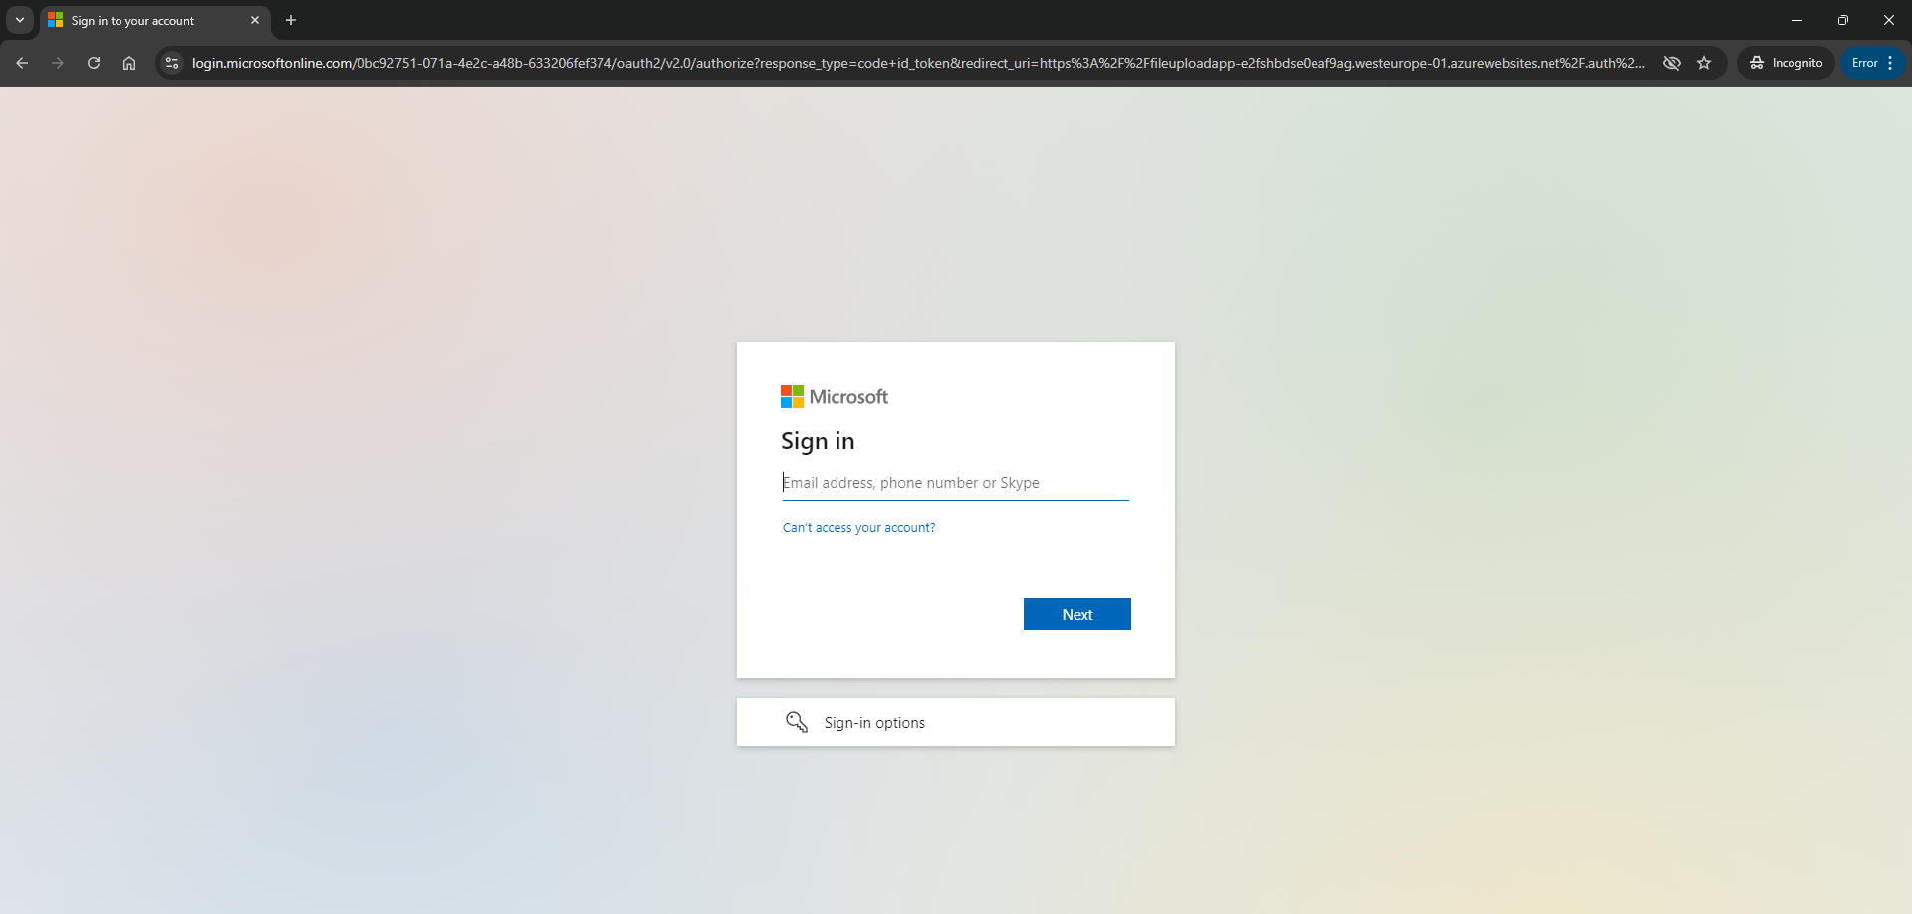

-After that the website will be available



-Then click “ upload “ and select the design you want to upload

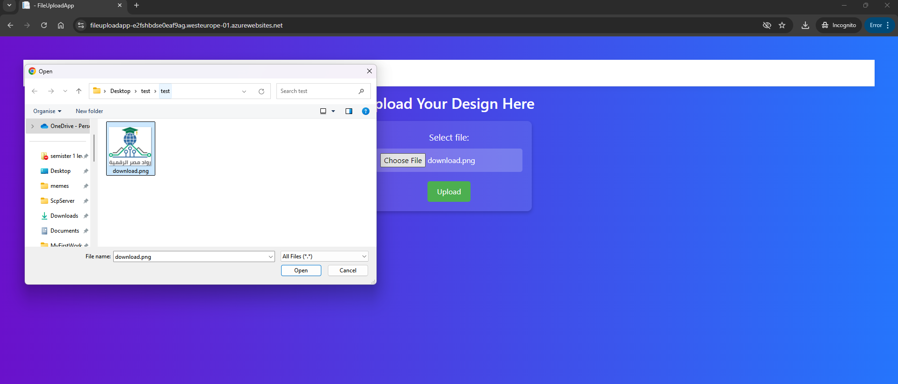



- The design will appear in the file share in HR computer

